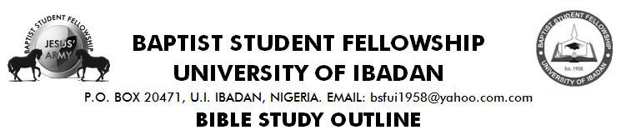

**Text- Phil 2:19-23, Acts 16:1-3**

**CHARACTER STUDY ON TIMOTHY** **29TH NOV, 2018**

**BACKROUND STUDY OF THE LIFE OF TIMOTHY**

Timothy - meaning “son of honour", was the son of Eunice who was a Jew and his father was a Greek. He lived in Lystra. He was a true son of Paul in faith. One, whom Paul converted, circumcised and ordained. He helped Paul in his missionary journeys.

He was a young minister who was ordained and circumcized as an instrument to be used by God - Acts 16:1-3, 1 Tim 3:11-14, 2 Tim 1:6.

**HIS GODLY VIRTUES**

* Trustworthy. - 1 Tim 6:20, 1 Cor. 4:17.
* Good reputation. - Acts 16:2.
* Unfeigned faith nurtured by his mother and grandmother - 2 Tim 1:5, 2 Tim 3:15, Prov. 22:6.
* Loyal and caring - Phil. 2:20.
* Selfless - Phil. 2:21-23.
* Devoted and zealous for what matters to Christ - Phil 2:19-22.

**WEAKNESSES**

* His health - 1 Tim 5:23
* Fear and intimidation because he is young - 1 Corinthians 16:10-11, 2 Tim 1:6-8

**CONCLUSION**

Timothy, a young man like us, was a dutiful man who gave himself upwards the course of the gospel. He was one whom Paul could trust to hand over the church to. Though he was very young, he didn’t allow his age to deter him from being used by God.

What is preventing you from serving God? Can God trust you? How is your commitment to your walk with Him? Can He Hand over lives to you?